Abhinesh.V

R2014002

**2nd Review of Major Project**

**Project Name: Rango Ride Hailing App.**

Rango is an mobile application that aims to improve the ride-hailing experience by incorporating innovation and optimizing convenience for users. The app provides a efficient and user-friendly platform for individuals to easily request rides, connect with drivers, and navigate to their destinations to travel with efficiency and ease.

**Key Features:**

1. Ride Search within Range.

2. Real-Time Vehicle Tracking.

3. One-time-password Verification on start and end of ride.

4. Review and Rating System.

5. Fare Estimation.

6. Driver and Vehicle Information.

**Tools:**

**Language: JavaScript / Nodejs**:

**JavaScrip**t is a versatile and widely-used programming language primarily used for creating interactive and dynamic elements on websites. It enables developers to enhance user experience by manipulating webpage content, handling user input, and communicating with servers. JavaScript can be executed directly in web browsers, making it an essential tool for front-end web development. It supports various programming paradigms, including procedural, object-oriented, and functional programming.

**Node.js** is a runtime environment that allows developers to run JavaScript code on the server-side. It utilizes the V8 JavaScript engine from Google Chrome to execute JavaScript code outside of the browser, enabling the creation of web applications, APIs, and other server-side functionalities. Node.js is known for its non-blocking, event-driven architecture, making it efficient for handling asynchronous operations. It has a rich ecosystem of packages and modules available through the Node Package Manager (npm), which facilitates rapid development and deployment of server-side applications.

**Framework: React-Native.**

React Native is a popular open-source framework for building mobile applications using JavaScript and React, a library for building user interfaces. With React Native, developers can create mobile apps for iOS and Android platforms using a single codebase. It allows developers to leverage their existing knowledge of React and apply it to mobile app development.

React Native uses native components to render the user interface, providing a native look and feel to the app. This results in better performance compared to purely web-based solutions. Developers can write platform-specific code when needed, ensuring that the app integrates seamlessly with the underlying operating systems.

One of the key advantages of React Native is its "write once, run anywhere" philosophy, which allows developers to reuse a significant portion of their codebase between different platforms, saving time and effort. However, platform-specific optimizations and UI adjustments may still be necessary to achieve the best user experience on each platform.

**Database: MongoDB:**

MongoDB is a popular open-source NoSQL database management system designed for the storage and retrieval of large volumes of unstructured or semi-structured data. Unlike traditional relational databases, MongoDB uses a document-oriented model, where data is stored in flexible, JSON-like documents. This allows developers to store and retrieve complex, hierarchical data structures without the constraints of a fixed schema.

**Debugging: Expo**

Expo is an open-source framework and platform that simplifies and accelerates the development of React Native applications. It provides a set of tools, libraries, and services that make it easier for developers to build, deploy, and manage React Native projects without the need for complex setup and configuration.

**Entity Relationship Diagram:**

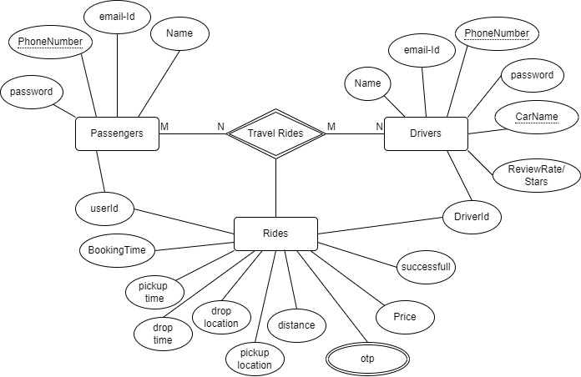

**Data Flow Diagram:**

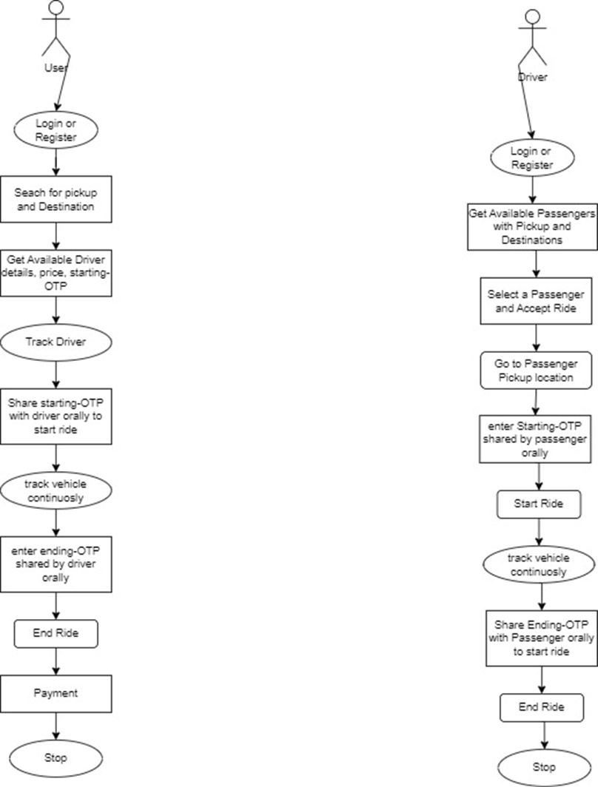

**Data Flow Diagram:**

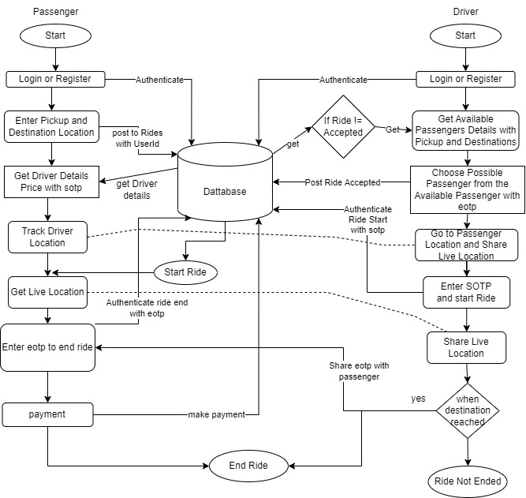

**Conclusion:**

Rango strive to provide an Easy user-centric platform that prioritizes

convenience, reliability, and efficiency in transportation services. The

app aims to provide a clear alternative to business centric transportation apps.